Topic 081
Art Movement- Cubism
Cubism was invented around 1907 in Paris by Pablo Picasso and Georges Braque.
Cubism was the first abstract style of modern art.
A Cubist painting ignores the traditions of perspective drawing and shows you many views of a subject at one time.
The Cubists introduced collage into painting.
The Cubists were influenced by art from other cultures, particularly African masks.
There are two distinct phases of the Cubist Style: Analytical Cubism (pre 1912) and Synthetic Cubism (post 1912).
Artists needed a more radical approach - a 'new way of seeing' that expanded the possibilities of art in the same way that technology was extending the boundaries of communication and travel. This new way of seeing was called Cubism.
The limitations of perspective were also seen as an obstacle to progress by the Cubists. The fact that a picture drawn in perspective could only work from one viewpoint restricted their options. As the image was drawn from a fixed position, the result was frozen, like a snapshot - but the Cubists wanted to make pictures that reached beyond the rigid geometry of perspective. They wanted to introduce the idea of 'relativity' - how the artist perceived and selected elements from the subject, fusing both their observations and memories into the one concentrated image. To do this the Cubists examined the way that we see. When you look at an object your eye scans it, stopping to register on a certain detail before moving on to the next point of interest and so on. You can also change your viewpoint in relation to the object allowing you to look at it from above, below or from the side. Therefore, the Cubists proposed that your sight of an object is the sum of many different views and your memory of an object is not constructed from one angle, as in perspective, but from many angles selected by your sight and movement. Cubist painting, paradoxically abstract in form, was an attempt at a more realistic way of seeing. The whole idea of space is reconfigured: the front, back and sides of the subject become interchangeable elements in the design of the work.

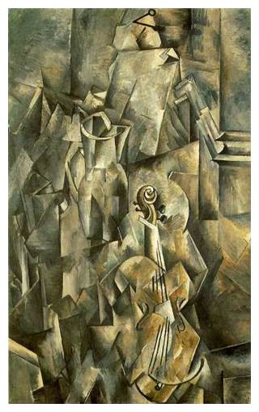
Cubism had two distinct phases. The early phase which lasted until about 1912 was called Analytical Cubism. Here the artist analyzed the subject from many different viewpoints and reconstructed it within a geometric framework, the overall effect of which was to create an image that evoked a sense of the subject. These fragmented images were unified by the use of a subdued and limited palette of colours.
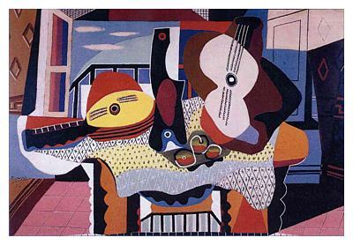
Influenced by the introduction of bold and simple collage shapes, Synthetic Cubism moved away from the unified monochrome surfaces of Analytic Cubism to a more direct, colorful and decorative style. Although synthetic cubist images appear more abstract in their use of simplified forms, the other elements of their composition are applied quite traditionally. Interchanging lines, colours, patterns and textures that switch from geometric to freehand, dark to light, positive to negative and plain to patterned, advance and recede in rhythms across the picture plain.

Topic 082
Art Movement- Futurism
Committed to the new, its members wished to destroy older forms of culture and to demonstrate the beauty of modern life - the beauty of the machine, speed, violence and change.
The Futurists were fascinated by the problems of representing modern experience, and strive to have their paintings evoke all kinds of sensations - and not merely those visible to the eye. At its best, Futurist art brings to mind the noise, heat and even the smell of the metropolis.
The Futurists were fascinated by new visual technology, in particular chrono-photography, a predecessor of animation and cinema that allowed the movement of an object to be shown across a sequence of frames. This technology was an important influence on their approach to showing movement in painting, encouraging an abstract art with rhythmic, pulsating qualities.
Their aim was to portray sensations as a “synthesis of what one remembers and of what one sees”, and to capture what they called the ‘force lines’ of objects.
The City Rises (1910)
Artist: Umberto Boccioni
Artwork description & Analysis: The City Rises is often considered to be the first Futurist painting. Here, Boccioni illustrates the construction of a modern city. The chaos and movement in the piece resemble a war scene as indeed war was presented in the Futurist Manifesto as the only means toward cultural progress. The large horse races into the foreground while several workers struggle to gain control, indicating tension between human and animal. The horse and figures are blurred, communicating rapid movement while other elements, such as the buildings in the background, are rendered more realistically. At the same time, the perspective teeters dramatically in different sections of the painting. The work shows influences of Cubism, Impressionism, and Post-Impressionism, revealed in the brushstrokes and fractured representation of space.
Oil on canvas - Museum of Modern Art
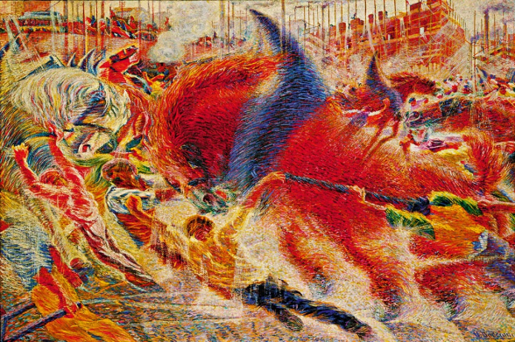
Unique Forms of Continuity in Space (1913)
Artist: Umberto Boccioni
Artwork description & Analysis: Frustrated by the constraints of the canvas, Boccioni found it more effective to explain Futurist principles of movement in a three-dimensional form. Unique Forms of Continuity in Space captures the essence of a figure in motion, rendered in geometric forms that convey an effortless grace and speed. Draped clothing appears to blow in the wind as the ambiguous figure strides forward, creating an aerodynamic effect. As homage to Auguste Rodin, Boccioni's sculpture is armless, referencing the "incomplete" Walking Man and the classical Greek statue, Nike of Samothrace.
Bronze - Museum of Modern Art, New York
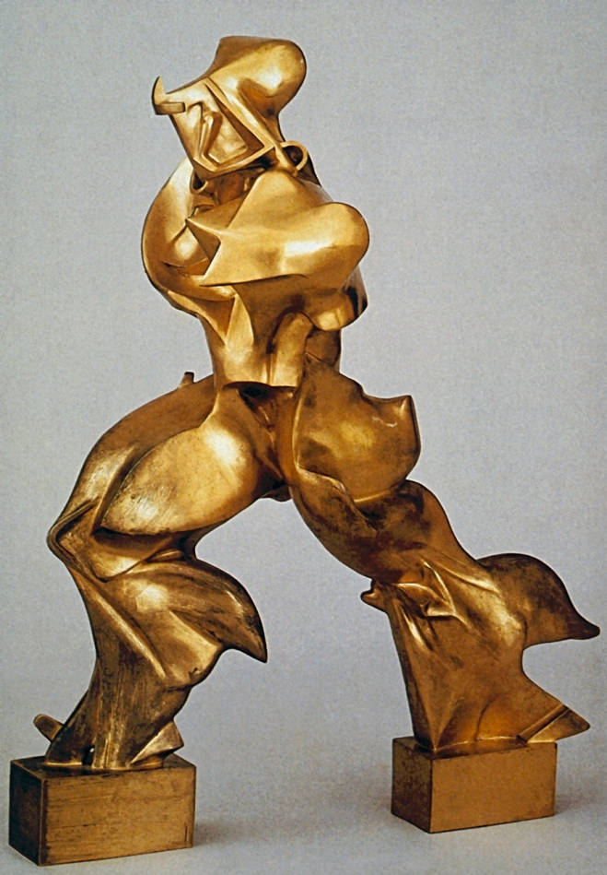

Topic 083
Art- Movement- Dadaism
Dada's weapons of choice in their war with the establishment were confrontation and provocation. They attacked traditional artistic values with irrational attitudes and provoked conservative complacency with outrageous statements and actions. They also launched a full scale assault on the art world which they saw as part of the system. It was considered equally culpable and consequently had to be toppled. Dada questioned the value of all art and whether its existence was simply an indulgence of the bourgeoisie.
The great paradox of Dada is that they claimed to be anti-art, yet here we are discussing their artworks. Even their most negative attacks on the establishment resulted in positive artworks that opened a door to future developments in 20th century art. The effect of Dada was to create a climate in which art was alive to the moment and not paralyzed by the traditions and restrictions of established values.
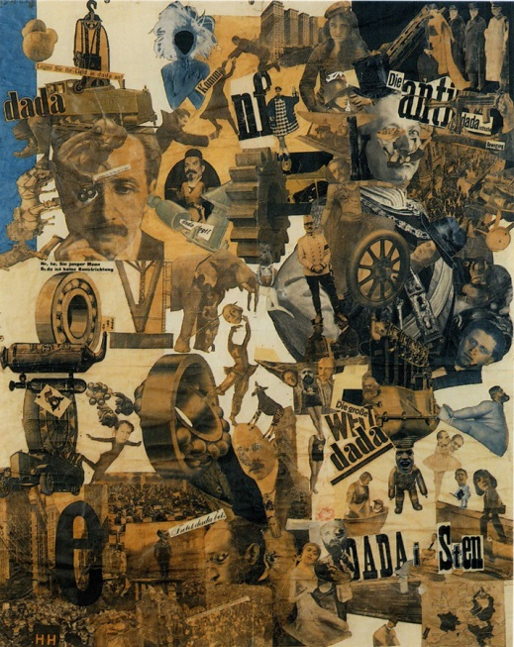
RAOUL HAUSMANN (1886-1971)
'ABCD' 1920 (collage)

When you first look at this work your eye is immediately drawn to its main theme: the letters 'ABCD' which are clamped in the teeth of a photographic self portrait. A spiraling arrangement of ticket stubs and typographic elements frame the artist's head. It is difficult to ignore the communicative power of the letters and numbers and you cannot help but enter into a dialogue in an attempt to make sense of them. It's an impossible task but there are just enough recognizable elements to keep your curiosity engaged. The text on the 'MERZ' ticket translates as 'Raoul Hausmann as Emotional Margarine', a sarcastic comment on the Expressionists' painting technique.
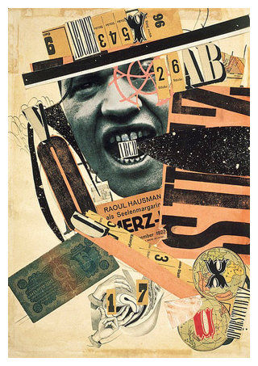
RAOUL HAUSMANN (1886-1971)
'The Spirit of Our Time', 1920 (assemblage)

‘Spirit of Our Time’ is a sculptural metaphor for the inability of the establishment to inspire the changes necessary to rebuild a better Germany. It is a satirical illustration of Raoul Hausmann’s statement that the average supporter of what he considered to be a corrupt society “has no more capabilities than those which chance has glued to the outside of his skull; his brain remains empty”. This blockhead of a hat maker’s dummy can only experience that which can be measured by the range of mechanical equipment attached to the outside of his head - a ruler and tape rule, the movement of a pocket watch, a jewellery box containing a typewriter wheel, some brass knobs from a camera, a leaky telescopic beaker of the kind that was issued to German soldiers during the World War 1, and an old purse nailed to the back of his head. With his eyes deliberately left blank, the ‘Spirit of Our Time’ is a blind automaton whose blinkered attitude excludes any possibility of creative thought.

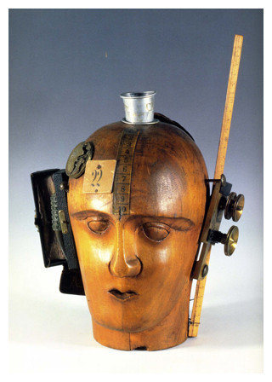
JEAN (HANS) ARP (1886-1966)
'Rectangles Arranged According to the Laws of Chance' 1917 (collage)

From a pure Dada perspective, what should have happened in 'Rectangles Arranged According to the Laws of Chance' is that Arp tore up sheets of paper into rectangles and dropped them onto a larger sheet, sticking them down where they landed 'according to the laws of chance' irrespective of their aesthetic appeal. This result would have been in accordance with Dada principles. What has actually happened is that there has been some degree of positional 'tweaking' after landing to improve the aesthetic interaction between the rectangles. You can't keep a good artist down.
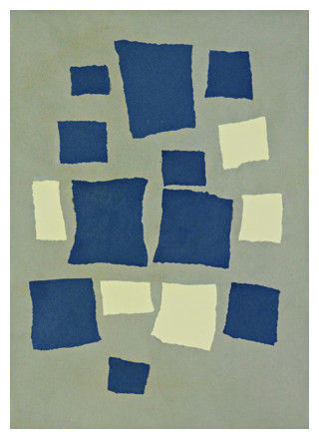

Topic 084
Art Movement- Surrealism
Surrealism was the 20th century art movement that sought to liberate creativity from the limitations of rational thought by exploring the hidden depths of the 'unconscious mind'. The Surrealists rejected the rational world as, in the words of André Breton, 'it only allows for the consideration of those facts relevant to our experience'. They sought a new kind of reality that was informed by the insights of the 'unconscious mind'; a heightened reality that was only achievable in a world of dreams and the imagination.
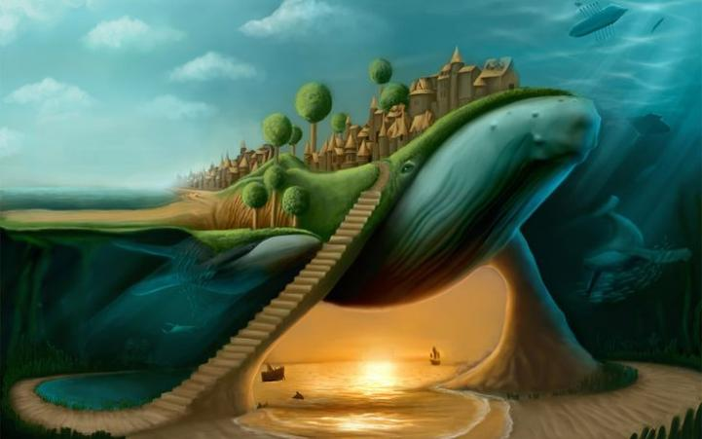
Surrealism is a cultural movement that began in the early 1920s, and is best known for its visual artworks and writings. The aim was to "resolve the previously contradictory conditions of dream and reality." Artists painted unnerving, illogical scenes with photographic precision, created strange creatures from everyday objects and developed painting techniques that allowed the unconscious to express itself.
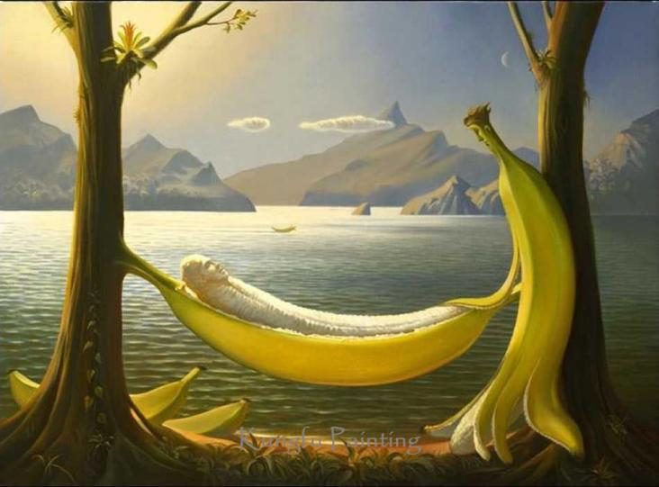

SALVADOR DALI (1904-1989)
Metamorphosis of Narcissus, 1937 (Oil on Canvas)

Dali was enthralled by certain delusional aspects of paranoia: how a person sees evidence of one thing and irrationally interprets it as another. By entering a self induced paranoiac state he was able to contemplate one form and conceive it as another - a kind of illusionistic double-take. True to Surrealist form, Dali adopts a mental disorder and turns it into an mechanism for mining the 'unconscious mind'. He called this his 'paranoiac-critical' method and he used it repeatedly in his classic surrealist paintings of the 1930's. Dali's works of this period were also very accessible to the wider public due to the virtuosity of his painting technique. He was able to create very believable images whose lifelike description convinces us that this unconscious world of his dreams is real.

Topic 085
Modernism and Post-Modernism
Abstract Expressionism movement encompassed two broad groupings. These included: action painting and color field painting.
It involved dripping thinned paint onto raw canvas laid on the ground using wide and rhythmic sweeps of a large and loaded brush (if a brush was used) or, more usually direct from the can - a far cry from the traditional painterly method whereby pigment was applied by brush to a canvas on an easel. Pollock worked in a highly spontaneous improvisatory manner, famously dancing around the canvas pouring, throwing and dripping paint onto it. By doing this, he claimed to be channelling his inner impulses directly onto the canvas, in a form of automatic or subconscious painting.
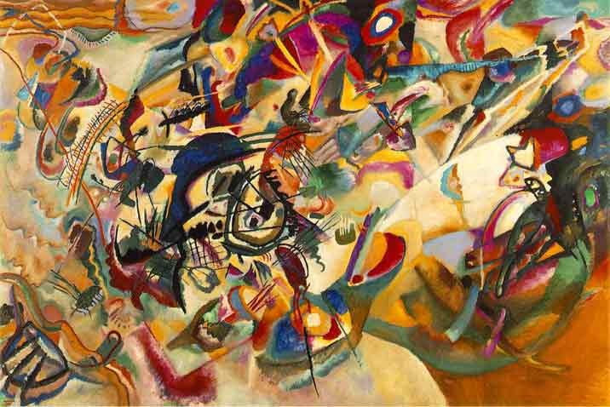
He impulse behind Colour Field painting was reflective and cerebral, characterized by simple pictorial imagery designed to create emotional impact. Rothko and Newman, among others, described their desire to achieve the "sublime" rather than the "beautiful." A type of highly coloured minimalism, their style (according to Newman) aimed to liberate the artist from "all constraints of memory, association, nostalgia, legend, and myth that have been the devices of Western European painting." Rothko's own soft-edged rectangular shapes of glowing colour sought to envelop the viewer and trigger a semi-religious emotional experience, to the point of tears. Like Pollock and the action-painters, colour field paintings were executed on a monumental scale for optimum impact - not to invoke heroic grandeur but rather to influence and create an intimate relationship with the individual spectator. Rothko said, "I paint big to be intimate."
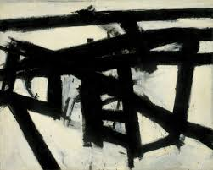
Number 1 (Lavender Mist) (1950)
Artist: Jackson Pollock
Artwork description & Analysis: One of thirty-two paintings in Pollock's 1950 solo exhibition at Betty Parson's New York gallery, Number 1 (Lavender Mist) was the only painting that sold. Despite critical praise and media attention, the artist did not garner sales of his famous drip paintings until later in his career. Pollock titled several paintings Number 1, and coded them with alternate titles. Thus, Number 1 (1949) and One, Number Thirty One, are closely related but upon close viewing differ slightly. Number 1 (Lavender Mist) exemplifies gestural abstraction, in which paint was poured or applied with extreme physicality to reflect the artist's inner mind. The color is expressive, while space is created through alternative layers and drips of opaque paint, creating a textured canvas surface that is nearly dizzying.
Oil on canvas - National Gallery, Washington DC
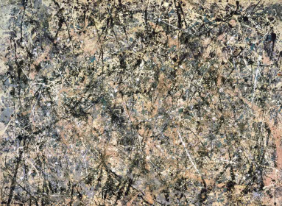
Red, Brown and Black (1958)
Artist: Mark Rothko
Artwork description & Analysis: Mark Rothko's paintings are titled by color variations, and all consist of soft, rectangular bands of color stretching horizontally across his canvases. Red, Brown, Black exemplifies a kind of chromatic abstraction known as Color Field painting. Color Field painters were concerned with brushstroke and paint texture, but they came to view color as the most powerful communication tool. Rothko's interests in mysticism, religion, and myth hearken back to the Surrealists, and his blocks of color are meant to provide a contemplative, meditative space in which to visually investigate one's own moods and affiliations with the chosen palette. He sought to distill an essence, or true nature, out of codified hues.
Oil on canvas - Museum of Modern Art
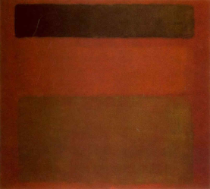
Action Painting
Action painting, sometimes called "gestural abstraction", is a style of painting in which paint is spontaneously dribbled, splashed or smeared onto the canvas, rather than being carefully applied. The resulting work often emphasizes the physical act of painting itself as an essential aspect of the finished work or concern of its artist.
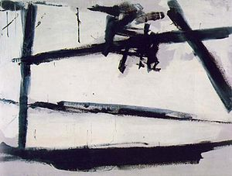
The style was widespread from the 1940s until the early 1960s, and is closely associated with abstract expressionism (some critics have used the terms "action painting" and "abstract expressionism" interchangeably). A comparison is often drawn between the American action painting and the French tachisme.
The term was coined by the American critic Harold Rosenberg in 1952, in his essay "The American Action Painters", and signaled a major shift in the aesthetic perspective of New York School painters and critics. According to Rosenberg the canvas was "an arena in which to act". While abstract expressionists such as Jackson Pollock, Franz Kline and Willem de Kooning had long been outspoken in their view of a painting as an arena within which to come to terms with the act of creation, earlier critics sympathetic to their cause, like Clement Greenberg, focused on their works' "objectness." To Greenberg, it was the physicality of the paintings' clotted and oil-caked surfaces that was the key to understanding them. "Some of the labels that became attached to Abstract Expressionism, like "informel" and "Action Painting," definitely implied this; one was given to understand that what was involved was an utterly new kind of art that was no longer art in any accepted sense. This was, of course, absurd." – Clement Greenberg, "Post Painterly Abstraction".

Rosenberg's critique shifted the emphasis from the object to the struggle itself, with the finished painting being only the physical manifestation, a kind of residue, of the actual work of art, which was in the act or process of the painting's creation. The newer research tends to put the exile-surrealist Wolfgang Paalen in the position of the artist and theoretician who used the term "action" at first in this sense and fostered the theory of the subjective struggle with it. In his theory of the viewer-dependent possibility space, in which the artist "acts" like in an ecstatic ritual, Paalen considers ideas of quantum mechanics, as well as idiosyncratic interpretations of the totemic vision and the spacial structure of native-indian painting from British Columbia. His long essay Totem Art(1943) had considerable influence on such artists as Martha Graham, Isamu Noguchi, Jackson Pollock, Mark Rothko and Barnett Newman; Paalen describes a highly artistic vision of totemic art as part of a ritual "action" with psychic links to generic memory and matrilinear ancestor-worship.

Over the next two decades, Rosenberg's redefinition of art as an act rather than an object, as a process rather than a product, was influential, and laid the foundation for a number of major art movements, from Happenings and Fluxus to Conceptual, Performance art, Installation art and Earth Art.
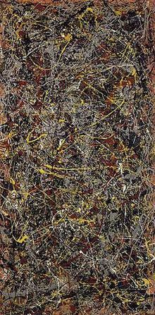

Pop Art
Reasons for the emergence of pop art:
- Political Frustration and Cultural reaction
- In 1946, there were 7000-8000 television sets in America, the cound became 40 million in 10 years.
- Television became source of information and advertisement
- Athletic events were promoted in an unmatched way
- Comedy, Action and Games became popular interests
- The rise in television viewing also benefited food industry as frozen meals used as television dinners became popular
- Stereotype TV programs portraying a family in fixed roles
- Cinemascope Screening and Radio also competed and grew in number
- Rock N Roll and Beats Movement
- Spending on Cars and Fashion
- Rebellion in Youth
- Toys and Food
Conceptual Foundation of Pop Art
Instant Meaning
In Abstract Expressionism, a viewer needed to intellectually grasp the idea behind the work which often involved complexity and obscurity, whereas, Pop Art relied on meanings that are communicated instantaneously. The use of popular imagery was a consideration coming from this viewpoint.
Art Can be Made From Anything
The traditional art had fix parameters as far as the materials were concerned. For instance painting was done on canvas using oil colors, sculpture was done using bronze or wood. The Pop artists opened a way for using anything as a material in producing art works. The things could be taken from everyday household items to waste and garbage items.
The Idea is More Important
The product in traditional art scenario was considered ‘work itself’ and therefore be it a painting, sculpture, etching or a carving. Pop art emphasized the importance of Idea over the form. The form occupied a second position in the order of preference. This trait was coming from previous art movements such as Dadaism.

Topic 086
Crux of the Course
In this course of Art, Craft and Calligraphy, we read about the following major topic and learn about practical example of art.
- Definitions and forms of Art
- Elements and principles
- Interpretation and Judgment
- Art Movement
- Teaching
Lesson No. 087
Drawing: Basic Drawing Technique
(Demonstration video)
It is demonstration video about the Drawing and its basic technique.

Lesson No. 088
Drawing: Butterfly
(Demonstration video)
It is demonstration video about the drawing of a Butterfly.

Lesson No. 089
Drawing: Kitten
(Demonstration video)
It is demonstration video about the drawing of a Kitten.

Lesson No. 090
Drawing: Parrot
(Demonstration video)
It is demonstration video about the drawing of a Parrot.

Lesson No. 091
Drawing: Owl
(Demonstration video)
It is demonstration video about the drawing of a Owl.

Lesson No. 092
Drawing: Rabbit
(Demonstration video)
It is demonstration video about the drawing of a Kitten.
Lesson No. 093
Drawing: Mouse
(Demonstration video)
It is demonstration video about the drawing of a Mouse.

Lesson No. 094
Drawing: Parts of Face
(Demonstration video)
It is demonstration video about the drawing of parts of Face.

Lesson No. 095
Art: Flower Painting
(Demonstration video)
It is demonstration video about the art of flower painting .

Lesson No. 096
Craft: Butterfly
(Demonstration video)
It is demonstration video about the craft of a Butterfly.

Lesson No. 097
Craft: Cat
(Demonstration video)
It is demonstration video about the craft of a Cat.

Lesson No. 098
Craft: Boys and Girls
(Demonstration video)
It is demonstration video about the craft of boys and girls.

Lesson No. 099
Craft: Windmill
(Demonstration video)
It is demonstration video about the craft of a Windmill.

Lesson No. 100
Sculpture: Flower Model
(Demonstration video)
It is demonstration video about the sculpture of a flower model.

Lesson No. 101
Sculpture: Animal Model
(Demonstration video)
It is demonstration video about the sculpture of a animal model.

Lesson No. 102
Sculpture: Village Model
(Demonstration video)
It is demonstration video about the sculpture of a village model.

